Research - ICOM 4998 (March 8-12)

Solar District Cup

Jeziel E. Torres Vazquez

Email: [jeziel.torres1@upr.edu](mailto:jeziel.torres1@upr.edu)

**Abstract:** This week the OpenDss team made a meeting to discuss some new code on the program. This is going to help make the final report, have more data and justify our decision for the components.

**1 Introduction**

OpenDss is a powerful program. You can see and plot every graph and data that is needed to make decisions for design and components. This week the OpenDss Team made a meeting to discuss the new code added to the new final delivery code. This included some lines that will add battery to the circuit created in OpenDss. Also monitors to check how everything is working and check the understanding of the team on what is really happening in the code.

**2 Work done in the week**

With OpenDss we can create a large circuit and check if there is any problem with the connections or components. This program really helps in understanding what is really happening with all the components and their behavior.

The OpenDss team scheduled a meeting to talk and discuss about the new lines of codes added to the program. In this meeting Angel presented the new lines and started explaining what they do in the code. The first lines were for the battery bank. This will help connect it to the circuit and make the circuit complete with almost all the parts the judges are asking.

This lines where necessary so the program can know how much capacity the battery has. This will help to si the circuit can simulate the behavior of the battery in the circuit and how this can be good or bad. This line of code remains commented because we don't have all the specs for the battery yet. We are waiting on the final decision on the battery to put all the specs in the circuit.

The other lines of code where the monitors. These lines were coded by me and are connected in the PV arrays to monitor the Voltage and plot it. There are 6 PV arrays, so I connected a monitor in each array. Also Angel coded a new monitor that will check the active and reactive power of the battery in the Science Building. This monitor is commented on the code because we are waiting on the battery specs.

The last thing added that was done is on the excel files that were provided by the design team. These files have the outputs of the power from the PV arrays. The program that they use is called Aurora. We divided the values by 1000 because it was given in W/m^2 and OpenDss wants them in kW/m^2. This value is the irradiance that the PV received throughout the day.

For next week my task is to work with Angel Figeroa on the solar mounts. We talked to the team in the Monday meeting and they decided to go for fixed solar roof mounts. Angel and I are going to schedule a meeting to search for the mounts.

**3 Graphs, tables, and picture**

Here is the new addition to the code:

1. Battery code in OpenDss

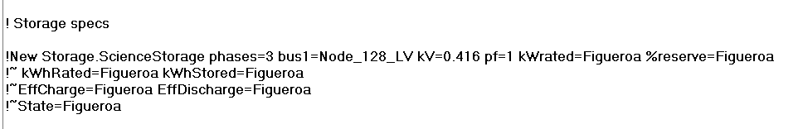

1. Monitors for the PV arrays

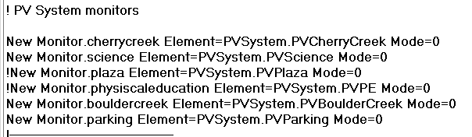

1. Monitor for battery bank

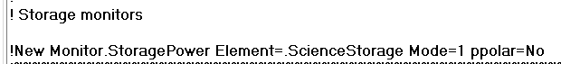

**4 Conclusion**

This week was really important for the OpenDss Team. With the new additions to the code we can start with the Distribution System Impact Analysis report. The monitors will give the report more credibility. This is because we can prove why the choice where made and how this where the best choices for the reneubale system. On the other hand, when we get the specs on the battey, the code is already written. This will provide speed to the process of not having to start doing research on topics. We are really motivated to make the best report possible and with these new additions this can be made much easily and efficiently.